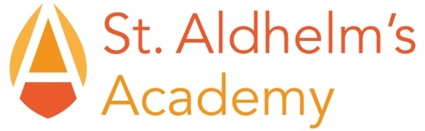

St Aldhelm’s Academy
AAC Members’ Attendance Record
2016-17

Meeting | Attendees | Apologies
19.10.2016 | Gerry Halley-Gordon  Sian Thomas  Jon Webb  Debbie Barrett  Sue Evans-Thomas  Shelley Fripp  Sarah Bell
6.2.17 | Gerry Halley-Gordon  Sian Thomas  Jon Webb  Debbie Barrett  Sue Evans-Thomas  Sarah Bell  Hayley Yarrow | Shelley Fripp
11.5.17 | Gerry Halley-Gordon  Jon Webb  Sue Evans-Thomas  Shelley Fripp  Sarah Bell  Hayley Yarrow

Outstanding Achievement for All

