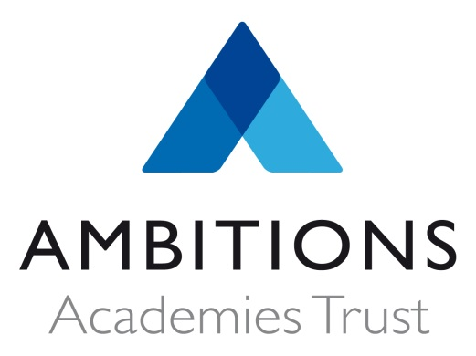
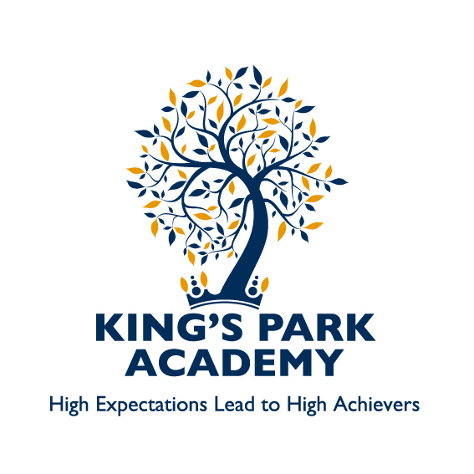

King’s Park Academy
AAC Members’ Attendance Record
2016-17

Meeting | Attendees | Apologies
16 November 2016 | Kay Errington, Catherine Phillips, Lauren Dean, Jez Du Puy, Cathy Lewis, Sarah Beer, Lindsey Henry | Samuel Badger
1 March 2017 | Kay Errington, Catherine Phillips, Lauren Dean, Samuel Badger, Jez Du Puy, Cathy Lewis, Sarah Beer, Helen Butler, Lindsey Henry
12 July 2017 | Kay Errington, Catherine Phillips, Lauren Dean, Jez Du Puy, Cathy Lewis, Helen Butler, Lindsey Henry | Samuel Badger, Sarah Beer

Outstanding Achievement for All

